**StatsLib**

* **Mean Median and Mode**
  + Takes in Arraylist and returns a double value
  + Given first is the Method being used to test the mean median and mode methods
  + Output 1
    - There are an odd amount of numbers where and two numbers have an equal amount of similar elements
  + Output 2
    - There are an even amount of numbers and more 3’s than any other number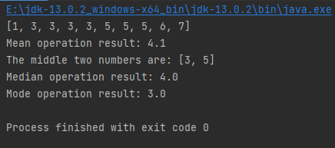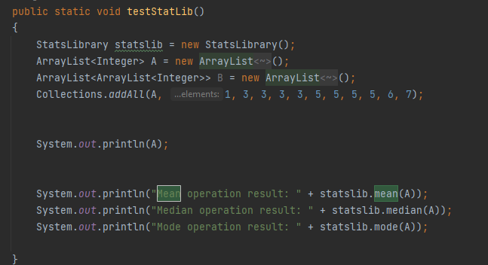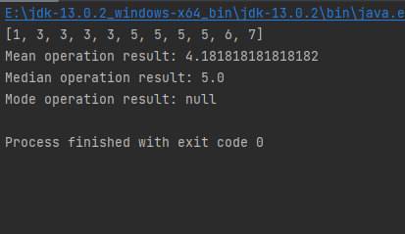
* **Standard Deviation**
  + Input an ArrayList and returns a double value

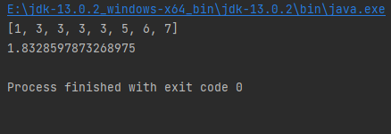

* **Combination, Permutation and Factorial** 
  + Returns the the values of each as a BigInteger

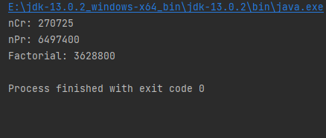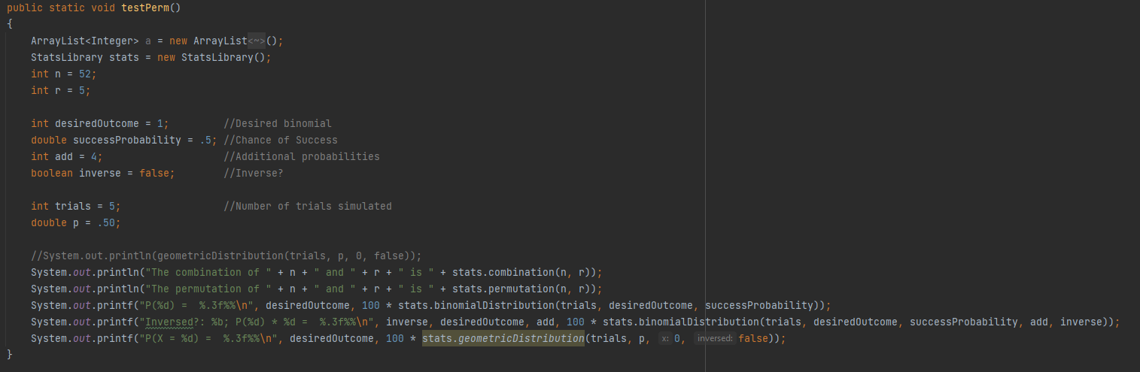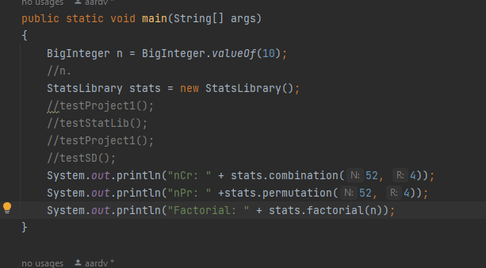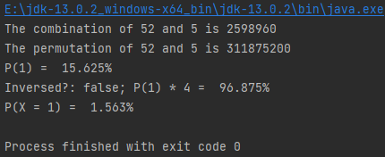

* **Union Intersection and Complement**
  + I included a testing method within this portion of the program which returns true if the complement/intersection/union return the expected output
  + You can see this in the second screenshot Where the “vs” separates the expected from the result. If the strings are the same then the program outputs a Passed++++... line otherwise it outputs a failed—....... Line

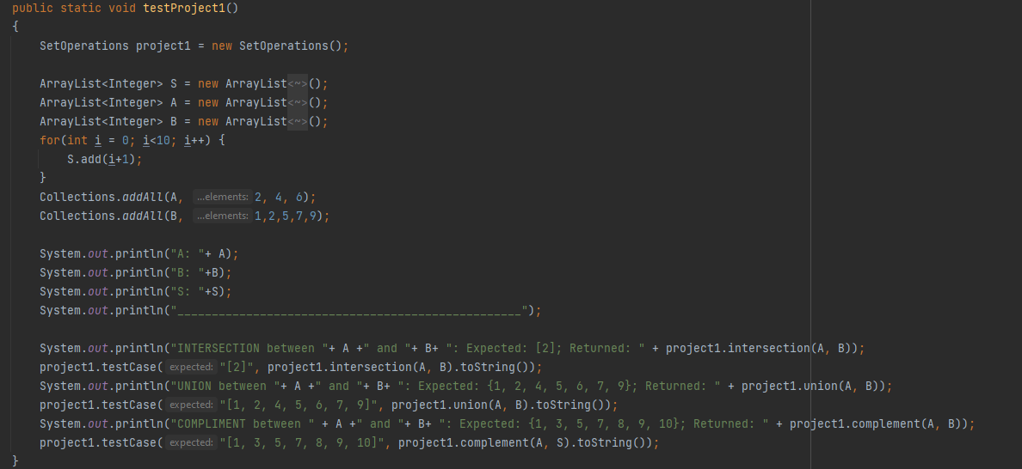

**Test Method Output:**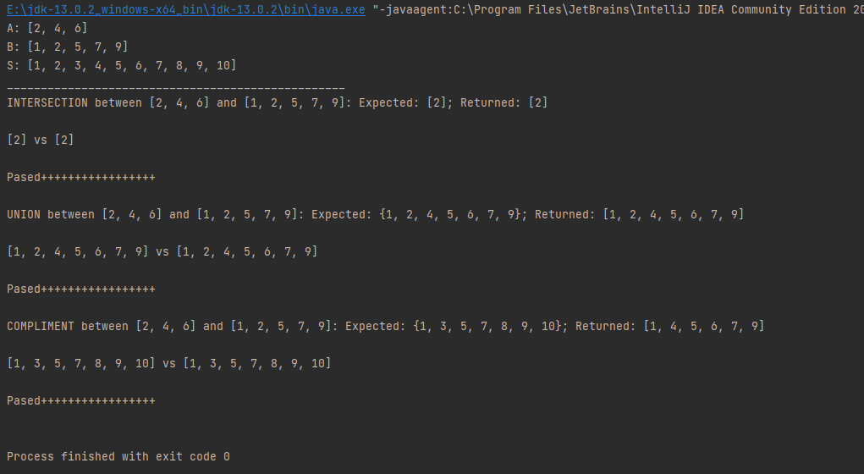

* **Monty Hall Program**
  + This simulation outputs the results for switching the door and choosing to hold your initial choice
  + 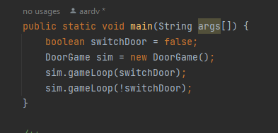
  + **Output for when you run the main method(4 Lines)**

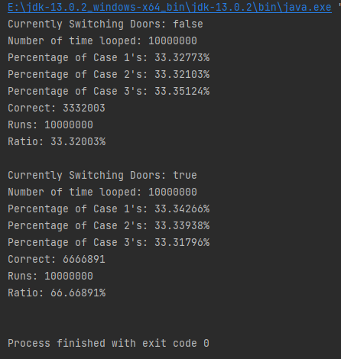

* An important part of this program is showing that the doors are actually randomly generated as opposed to this all being a magic trick so for clarity's sake I included the Percentage of the Different Door Cases; Case 1 is a situation where the first door has a car behind it, Case 2 the second door, and Case 3 the third door. The output also shows the number of correct cases, Runs performed and then Shows the Ratio of the two in percent form
* **Birthday Paradox**
  + **Main Method**

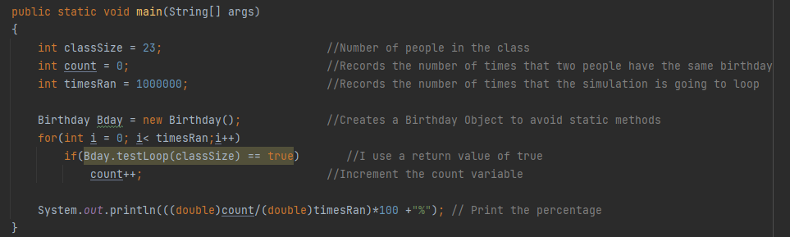

* **Person Class**

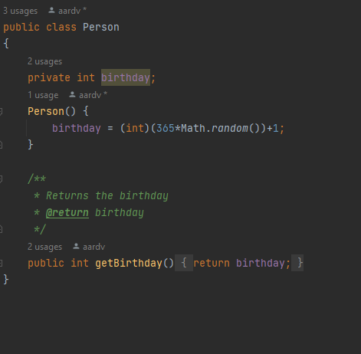

* Output From main method

